|  |  |
| --- | --- |
|  |  |

|  |  |  |
| --- | --- | --- |
| **InfoConnectSdnBhd**  **(302995-V)**  **Docuflo (MSC) SdnBhd**  **(735174-H)**  **Corporate Office**  15-B, Jalan SS 22/23, Damansara Jaya, 47400 Petaling Jaya,  Selangor Darul Ehsan  *Tel: +603 7722 2001*  *Fax: +603 7722 1994*  . | |  | | --- | | Version Number: V1.2 | |
| **PT. AsuransiJiwa BCA**  **User Requirements Specification (URS)**   * **Phase 2** * **Product Configurator** |
|  | |  |  | | --- | --- | | Date Prepared | : 08/06/2016 | | Author | : Andy Phan Chee Seng | |  |  | |  |  | |
| **PROPRIETARY NOTE**: *This document remains the property of* *InfoConnectSdn Bhd. All information herein is confidential. Neither the whole nor any part of this document may be used, reproduced or transmitted, in any form or by any means, electronic or mechanical, including recording or the use of any information storage and retrieval system, without the prior written consent of InfoConnectSdn Bhd.* | | |

**SIGNATURES PAGE:**

We, the undersigned below, mutually agreed and accepted the contents of this User Requirements Specification (URS) for the PT. AsuransiJiwa BCA, to be provided by InfoConnectSdn Bhd.

**VENDOR SIGNOFF – INFOCONNECT**

|  |  |
| --- | --- |
| Prepared By | Reviewed By |
|  |  |
| Name: Andy Phan Chee Seng  Title: Vice President  Date: |  |

**CUSTOMER SIGNOFF – BCA LIFE**

|  |  |  |
| --- | --- | --- |
| Reviewed/Accepted By: | | |
|  |  |  |
| Name: Vera Lisnan  Title: In Branch  Date: | Name: Iko  Title:  Date: | Name: Tony Liauw  Title: In Branch Division Head  Date: |
|  |  |  |
| Name: Lely Pekih  Title: Marketing Communication  Date: | Name: Yusuf Sutarko  Title: IT Development Head  Date: | Name: Gilbert Leman  Title: IT Division Head  Date: |
|  |  |  |
| Name:  Title:  Date: | Name:  Title:  Date: | Name:  Title:  Date: |
|  |  |  |
| Name:  Title:  Date: | Name:  Title:  Date: | Name:  Title:  Date: |

|  |  |
| --- | --- |
| Approved By | |
|  |  |
| Name: Yannes Chandra  Title: Director  Date: | Name: Honggo Djojo  Title: Director  Date: |

**AMENDMENT HISTORY:**

The table below contains a history of the changes made toURS of this project name. The version number corresponds to control number as indicated in front page.

|  |  |  |  |  |
| --- | --- | --- | --- | --- |
| **No.** | **Description of Amendment** | **Author** | **Version No.** | **Version Date** |
| 1 | Initial draft release | Andy Phan | 1.0 | 08/06/16 |
| 2 | * Added Min and Max Sum Assured to Mode of Payment table in Basic Plan Setup * Added Product Compilation screen | Andy Phan | 1.1 | 13/06/16 |
| 3 | Changes of Field Mapping and formula screen | Andy Phan | 1.2 | 27/06/16 |
|  |  |  |  |  |
|  |  |  |  |  |

TABLE OF CONTENTS

1 INTRODUCTION 7

1.1 OBJECTIVE 7

1.2 project Scope 7

1.3 abbreviations 8

1.4 study approach 8

2 USER REQUIREMENTS 9

2.1 Process flow OVERVIEW 9

2.2 Product configuration module OVERVIEW 9

2.2.1 Channel admin 9

2.2.1.1 MAIN CHANNEL ADMIN 10

2.2.1.2 SUB CHANNEL ADMIN 10

2.2.2 Age Method admin 11

2.2.3 Payment mode master 12

2.2.4 Fund type master 13

2.2.5 Fund house master 14

2.2.6 Fund master 15

2.2.6.1 FUND MASTER SETUP 15

2.2.6.2 PERFORMANCE HISTORY BENCHMARK 17

2.2.7 occupation master 17

2.2.8 currency master 18

2.2.9 Person type master 19

2.2.10 Basic plan setup 20

2.2.10.1 BASIC PLAN LISTING 20

2.2.10.2 BASIC PLAN SETUP 21

2.2.10.3 BASIC PLAN WORDING SETUP 26

2.2.10.4 RATES AND FORMULA SETUP 26

2.2.10.5 RATES MAPPING 27

2.2.10.6 FORMULA 28

2.2.11 Rider setup 29

2.2.11.1 RIDER LISTING 30

2.2.11.2 RIDER SETUP 31

2.2.11.3 RIDER WORDING SETUP 33

2.2.11.4 RATES AND FORMULA SETUP 34

2.2.11.5 RATES MAPPING 34

2.2.11.6 FORMULA 35

2.2.12 Additional wording 37

2.2.12.1 Additional wording (Insert wording) 38

2.2.13 Product setup 38

2.2.14 Illustration setup 40

2.2.14.1 ILLUSTRATION TABLE SETUP 40

2.2.14.2 ILLUSTRATION TABLE DETAIL 40

2.2.14.3 Formula 41

2.2.14.4 IMPORT RATES 42

2.2.14.5 FIELD MAPPING 43

2.2.15 Product compilation 44

2.2.16 Appendix 46

Table 1: Abbreviations 2

***Table 2: List of users*** 2

1. INTRODUCTION
   1. OBJECTIVE

The objective of the Product Configurator is to develop an admin module for BCA Life to maintain the Sales illustration product settings. The product setting is including of Channel Setting, Payment Mode setting, Fund Type, Fund House, Fund Master, Basic Plan Master, Rider Master, Product setup and etc.

The product setting will be compiled together with BLESS and it will be

ready for Agent to propose the product to the prospect.

* 1. project Scope

This document covers the features and functionality of the Product Configurator Module that discussed during the requirement gathering session that specifically customize for BCA Life.

* 1. abbreviations

Below is a list of abbreviations used in this document.

|  |  |  |
| --- | --- | --- |
| **No** | **Abbreviation** | **Description** |
| 1 | SI | Sales Illustration |

Table 1: Abbreviations

* 1. study approach

A series of user requirement study sessions has been conducted with the users of BCA Life. The users who have been involved in the user requirement study sessions are as follows:

|  |  |  |
| --- | --- | --- |
| **No** | **Name** | **Department** |
| 1. | Pak Yusuf Sutarko | PA |
| 2. | Pak Julius Luthena | IT/PM |
| 3. | Ibu Irene Poernomo | BA |
| 4. | Ibu Vera Lisnan | In-Branch |
| 5. | Pak Eko | In-Branch |
| 6. | Pak Tony Liauw | In-Branch |

***Table 2: List of users***

1. USER REQUIREMENTS
   1. Process flow OVERVIEW

Below is the Main Menu of the Product Configurator.

**Main Menu**

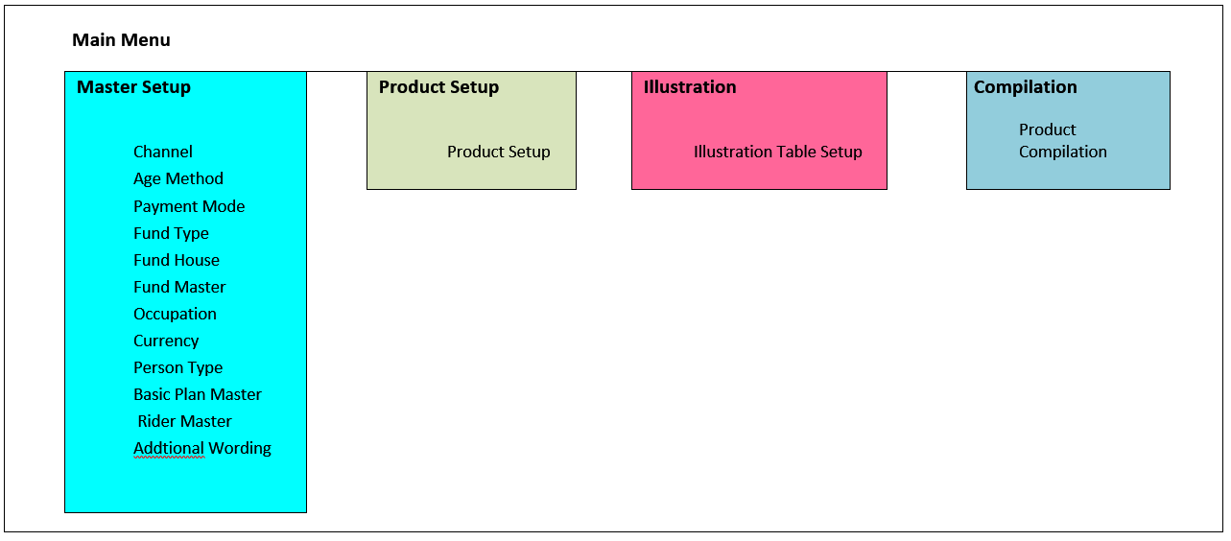

In order to complete the design cycle for a product, User must follow the step illustrate below.

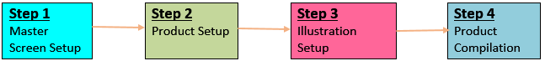

* 1. Product configuration module OVERVIEW

This section show the list of requirements captured for Product Configuration Module.

* + 1. Channel admin

Channel Admin is to maintain the distribution channel information.

The channel information maintain in this screen will display in the Basic Plan setup screen as an option for user to define whether the distribution channel is applicable for the basic plan. Channel distribution is divided into Channel distribution and Sub Channel distribution.

* + - 1. MAIN CHANNEL ADMIN

This section is to maintain main channel distribution.

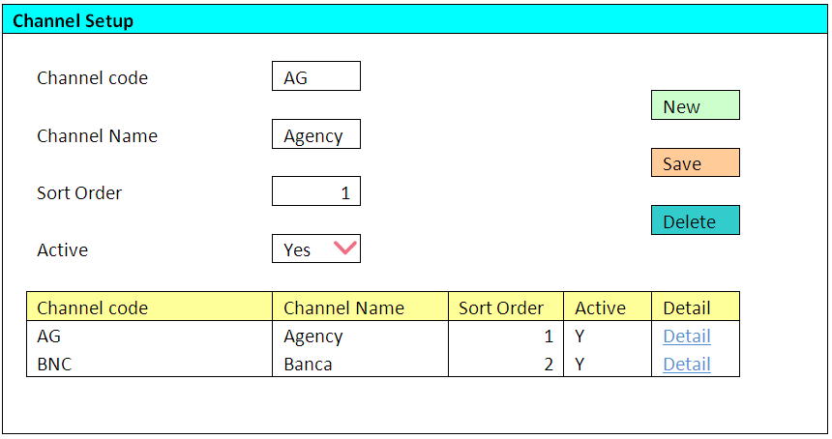

Features available

* Sorting
  + Sorting default by Channel code
  + Channel Name
  + Sort Order
  + Active
* Add new record
* Edit record by click on record listing.
* Delete record
* Active –Only Yes/ No option available

Validation

* Channel code must be unique
* All fields are mandatory
  + - 1. SUB CHANNEL ADMIN

This screen can be accessible from the “Details” link column in the Main channel admin.

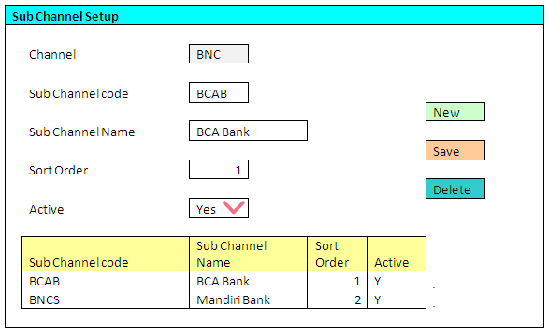

Features available

* Sorting
  + Sorting default by Sub Channel code
  + Sub Channel Name
  + Sort Order
  + Active
* Add new record
* Edit record by click on record listing.
* Delete record
* Active: –Only Yes/ No option available

Validation

* Sub Channel code must be unique
* All fields are mandatory

* + 1. Age Method admin

This section is to set the Age method default value and the Sorting order .The default value set in this maintenance screen will then display as a default selection for the Age method field inBasic Plan setup screen. User are not allowed to add or delete the Age method record in this section.

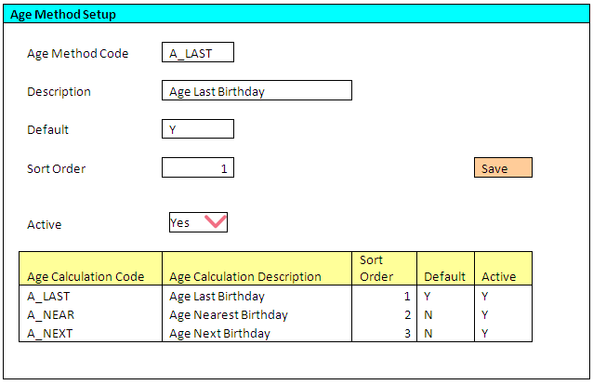

Features available

* Edit record by click on record listing.
* Active - Only Yes/ No option available

Validation

* Only one default value “Y” is allowed
* All field are not editable except default, sort Order and Active field.
* Default, sort order and active field are mandatory.
  + 1. Payment mode master

This section is to maintain the mode of payment information.

The mode of payment information that setup in this screen will display in the Basic Plan setup screen as an option whether the payment mode is allowable for the product. The Payment value and modal factor are use for calculation purposes.

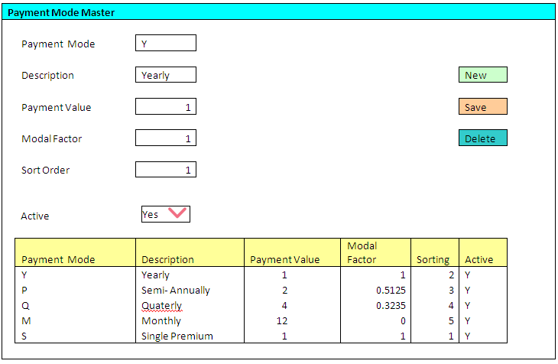

Features available

* Sorting
  + Sorting default by Payment mode
  + Description
  + Sort order
  + Active
* Add new record
* Edit record by click on record listing.
* Delete record
* Active: – Only Yes/ No option available

Validation

* Payment mode code must be unique
* All fields are mandatory
  + 1. Fund type master

This section is to maintain the fund type information.

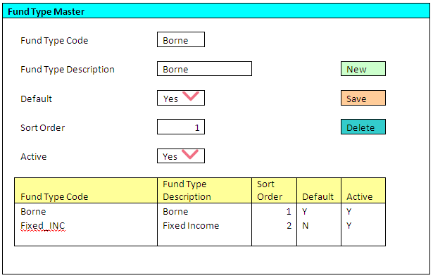

Features available

* Sorting
  + Sorting default by Fund Type Code
  + Fund Type Description
  + Sort order
  + Default
  + Active
* Add new record
* Edit record by click on record listing.
* Delete record
* Default: – Only Yes/ No option available
* Active :– Only Yes/ No option available

Validation

* Fund Type code must be unique
* All fields are mandatory
* Only one default value “Y” is allowed
  + 1. Fund house master

This section is to maintain the Fund house information

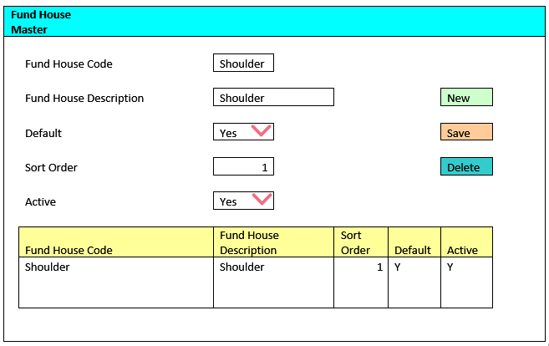

Features available

* Sorting
  + Sorting default by Fund House Code
  + Fund House Description
  + Sort order
  + Default
  + Active
* Add new Fund House
* Edit the Fund House information by click on record listing.
* Delete record
* Default :– Only Yes/ No option available
* Active :- Only Yes/ No option available

Validation

* Fund Type code must be unique
* All fields are mandatory
  + 1. Fund master

Fund Master is divided into 2 sections which is the Fund Master

* + - 1. FUND MASTER SETUP

The Fund Master Setup screen is to maintain the funds information that invest by the company.

The information setup in this screen will then show as an option if the Basic Plan is applicable for the particular Fund. Fund option is only applicable for unit-linked product.

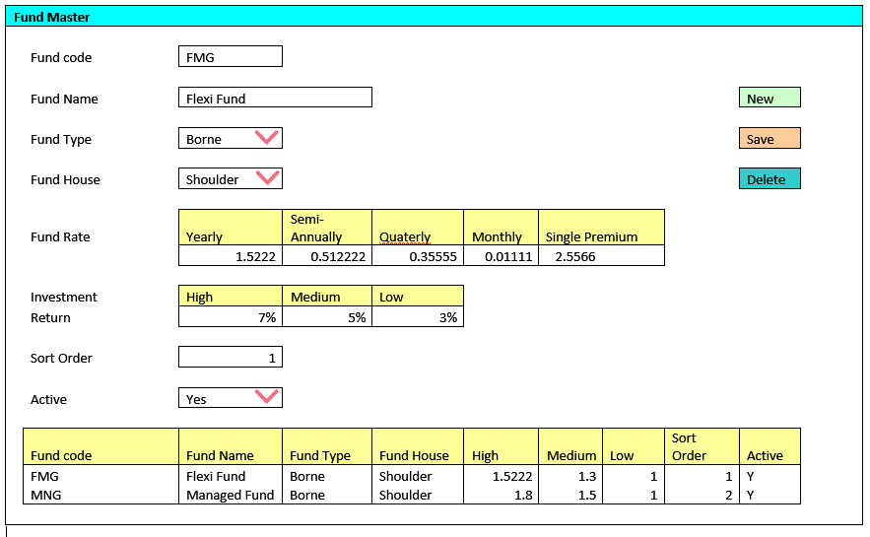

Features available

* Sorting
  + Sorting default by Fund Code
  + Fund Name
  + Fund Type
  + Fund House
  + High
  + Medium
  + Low
  + Sort Order
  + Active
* Edit record by click on record listing.
* Active :- Only Yes/ No option available
* Fund Type :– Listing are populated from the Fund Type Master
* Fund House :– Listing are populated from the Fund House Master

Validation

* Fund code must be unique
* All fields are mandatory
  + - 1. PERFORMANCE HISTORY BENCHMARK

This section is to maintain the history performance benchmark of the Fund. The benchmark information will be display in the sales illustration quotation to show the prospect the history performance of the fund.

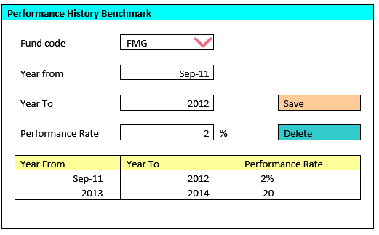

Features available

* To choose the fund type from the Fund code combo that maintain in the Fund Master setup screen.
* Edit record by click on record listing.
* Delete performance history fund
  + 1. occupation master

This section is to maintain the occupation information such as occupation loading and class. The occupation list is imported from the BLISS system for 1st time. Subsequently, it will maintain by user.

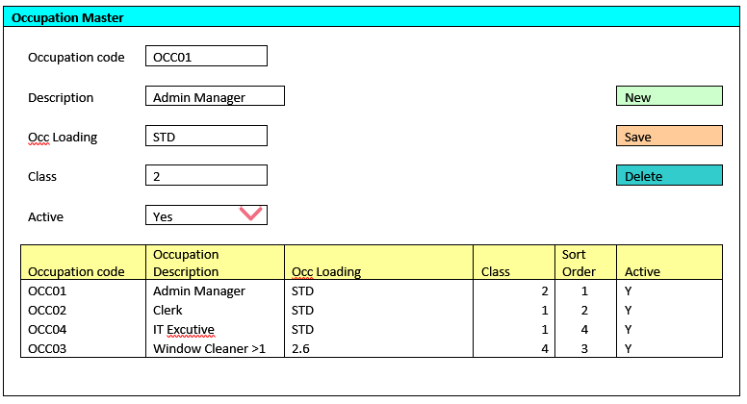

Features available

* Sorting
  + Sorting default by Occupation Code
  + Occupation Description
  + Occ Loading
  + Class
  + Sort Order
  + Active
* Edit the Fund information by click on record listing.
* Active :- Only Yes/ No option available

Validation

* Occupation code must be unique
* All fields are mandatory
  + 1. currency master

This section is to maintain currency information especially on the Selling value that always fluctuated. This currency information will display in the Basic Plan setup for user to choose currency allowable for the particular product. The premium computed will then convert to currency chosen by prospect. Pending BCA to provide the requirement which part of calculation will be affected.

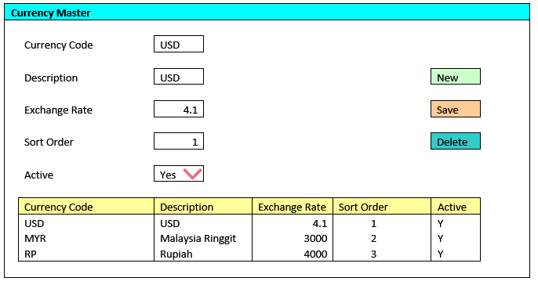

Features available

* Sorting
  + Sorting default by Currency Code
  + Description
  + Exchange Rate
  + Sort Order
  + Active
* Edit the Fund information by click on record listing.
* Active :- Only Yes/ No option available

Validation

* Currency code must be unique
* All fields are mandatory
  + 1. Person type master

This section is to maintain the Person covered that allow to attach to the Basic Plan and Rider. The list of person type will display as an option in the Basic Plan and Rider setup screen, User will then select the person type that can be attachable to the product and rider.

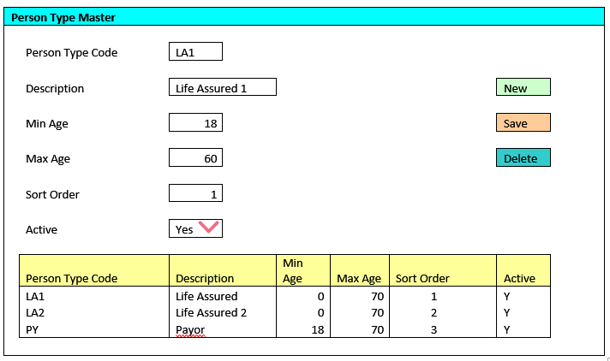

Features available

* Sorting
  + Sorting default by Person Type Code
  + Description
  + Min Age
  + Max Age
  + Sort Order
* Edit the Fund information by click on record listing.
* Active :- Only Yes/ No option available

Validation

* Person Type code must be unique
* All fields are mandatory
  + 1. Basic plan setup

The basic plan setup is divided into few sub module including of Basic Plan Listing, Basic plan setup, Wording setup and the Rates & formula setup.

* + - 1. BASIC PLAN LISTING

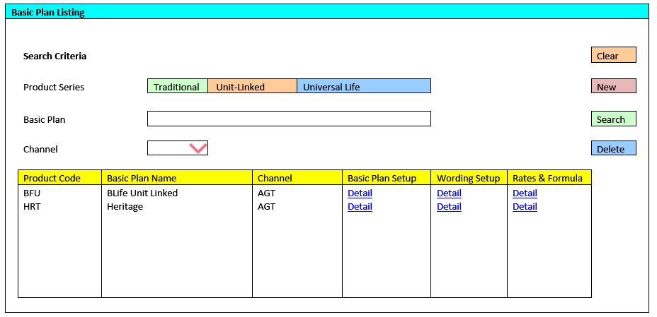

Features available

* Sorting
  + Sorting default by Product Code
  + Basic Plan Name
  + Channel
* Channel – if there is more than 1 channel, a comma (“,”) separator will be use. For example; AGT, BNC
* Click Clear to clear the searching field such as Product series, Basic Plan and channel
* Delete Record
* Add New Record
  + - 1. BASIC PLAN SETUP

The section is used to setup the basic plan information. The basic plan setup can be access by clicking on the Details link in Basic Setup Plan column.

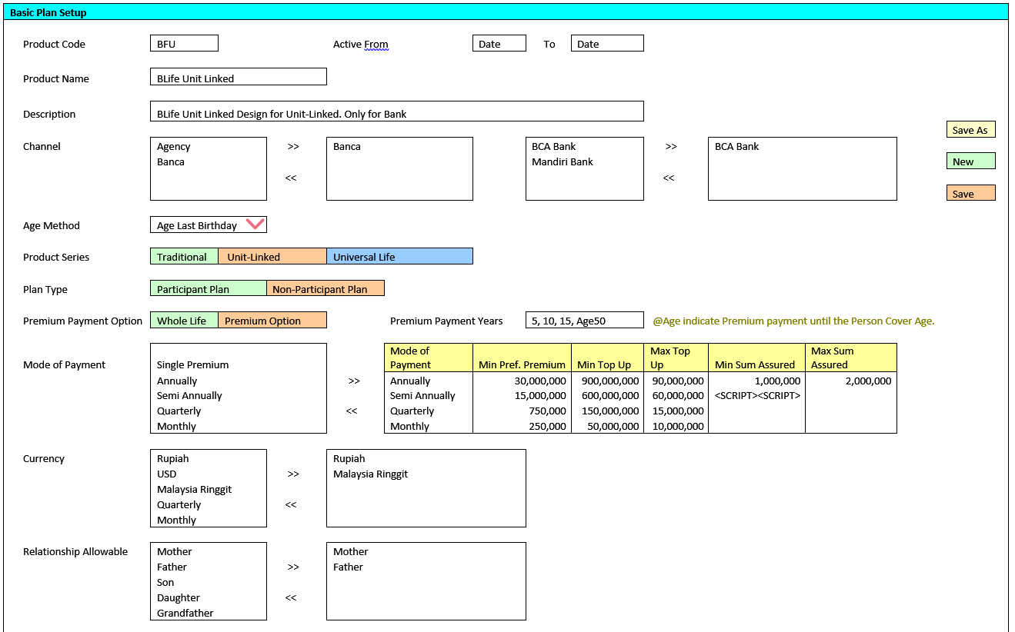

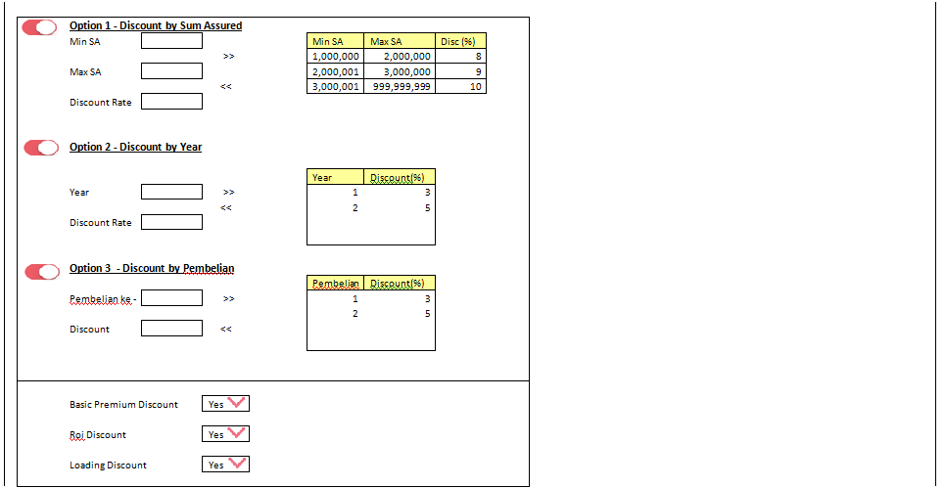

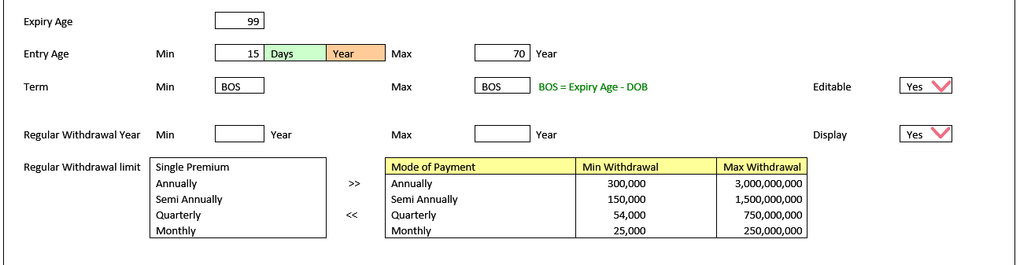

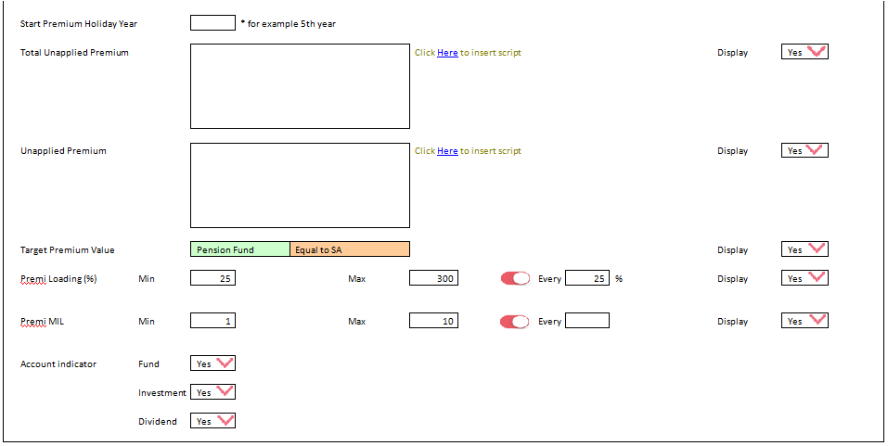

Features available

* Channel: - The Channel list are populated from the Channel master
* Active from and to – The Basic Plan in BLESS is only active within the date period else agent are not able to view the basic plan in the system
* Age: - The Age method list is populated from the Age Method master. The default value set in the master screen will be display as a default value in this screen.
* Premium Payment Option: -2 option available which are Whole Life and Premium
* Mode of payment: The mode of payment list is populated from the Mode of Payment master. User can select the mode of payment applicable for the product.
* Min Basic Sum Assured: - Can be input as numbers or script. A box will pop up to fill in the number or script when user click on the Min Sm Assured field.
* Max Basic Sum Assured: - Can be input as numbers or script. A box will pop up to fill in the number or script when user click on the Max Sum Assured field.
* Currency: - The Currency listing is populated from the currency Master setup. User can select more than 1 currency.
* Discount: – There are 3 types of discount available which consists the below and only 1 option is allow.
  + Discount by Sum Assured
  + Discount by Year
  + Discount by Pembelian
* Discount: - User to define what are the discount to be granted
  + Basic Premium Discount
  + Roi Discount
  + Loading Discount
* Min Entry Age: - Min Age can be set as ‘Days’ or ‘Year’
* Term: - Editable option is available to allow or not allow agent to edit the field in BLESS.
* Regular withdrawal: – There are option to set the Min and Max withdrawal amount for each payment mode
* Total Unapplied Premium: - To input script for auto calculation value in BLESS
* Unapplied Premium: - To input script for auto calculation value in BLESS. Display option is available to set whether to display the field in BLESS
* Premium Loading (%): – An option is available (every) to set the mod between the Min and Max value. For example: Min is 25, Max is 200 and mod is set to 25. The premium loading (%) display in the BLESS is 25, 50, 75, 100,125,150,175 and 200. There are also Display option to set whether to display the field in BLESS.
* Premi MIL – Option available (every) to set the mod between the Min and Max value. There are also Display option to set whether to display the field in BLESS
* Account distributor: – Consists of Fund, Investment and Dividend. No requirement provided for these field.
* The Basic Plan record can be cloned by clicking “Save as” button.

Validation

* Product code ** must be unique
* Active from **
* Active to **
* Product Name **
* Description **
* Channel **
* Age method **
* Product Series **
* Mode of Payment **
* Currency **
* Relationship allowable **
* If product Series “Traditional” is selected, below field will be disabled.
  + Minimum Preferred Premium
  + Min Top Up
  + Max Top Up
  + Roi Discount
  + Regular Withdrawal Year
  + Regular Withdrawal Limit
  + Start Premium Holiday Year
  + Target Premium value
  + Total Unapplied Premium
  + Unapplied Premium
  + Account Indicator
* Premi Loading (%) is mandatory if Display = Yes option is selected
* Premi MIL is mandatory field if Display = Yes option is selected

** Mandatory fields to key in.

* + - 1. BASIC PLAN WORDING SETUP

The screen is to set the basic plan wording that will display in the SI quotation report. It can be access from the Basic Plan wording column in Basic plan listing screen.

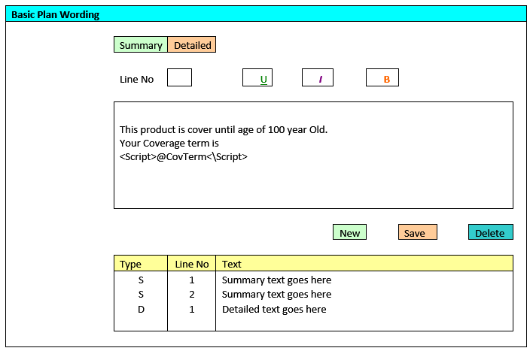

Features Available

* Summary or Detailed: – Basic Plan wording can add either to Summary or Detailed section.
* Text can be formatted to Underline, Italic or bold.
* Script can be inserted into the Text box. The script must be started with <Script> and ended with </Script>.

Validation

* All fields are mandatory
  + - 1. RATES AND FORMULA SETUP

User can create the formula related to Basic Plan such as basic plan premium in this screen. This screen can be accessible from the Rates and formula column in the Basic Plan listing screen.

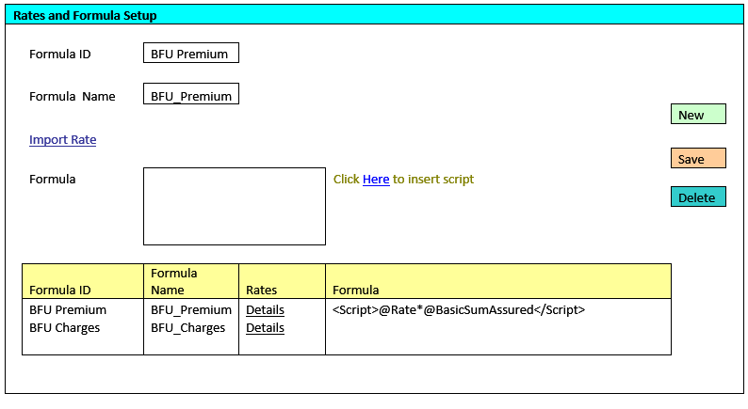

Validation

* + - Formula ID must be unique
    - All fields are mandatory
      1. RATES MAPPING

This screen can be accessible from the Rates and Formula setup screen by clicking on the Import rates link or the Rates Details column. The purpose of this section is to import the and map the rates field to the Predefined field so that the system knows what are the criteria to meet to retrieve the correct rates.

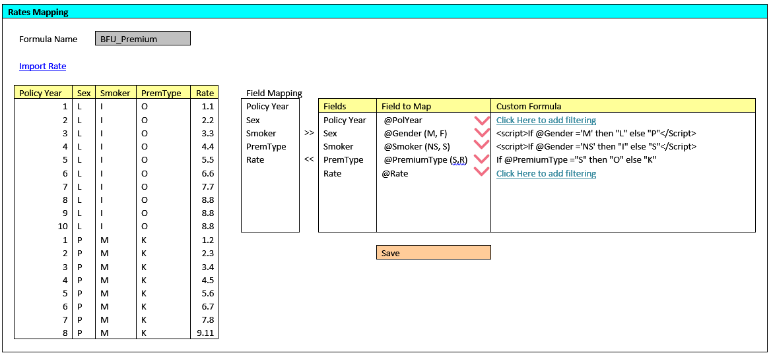

Features available

* Import rate: - Rates to be imported from excel file to the rates listing. Note: The system only recognizes excel format
* Field Mapping: - There are a list of Predefined field. User are required to map the rates field to the predefined field at the combo box provided.
* Custom Formula –User are able to add formula to map the rates if there is special condition. The formula screen will pop up when user click on the custom formula column.(Refer to 2.2.10.6)
  + - 1. FORMULA

The section below is the pop up screen from the Rates and Formula setup screen for user to code the script. Once the formula is saved, the formula will be populated to the formula textbox in the Main screen. This screen can be access from the “Click here to input script” in the Rates and Formula screen.

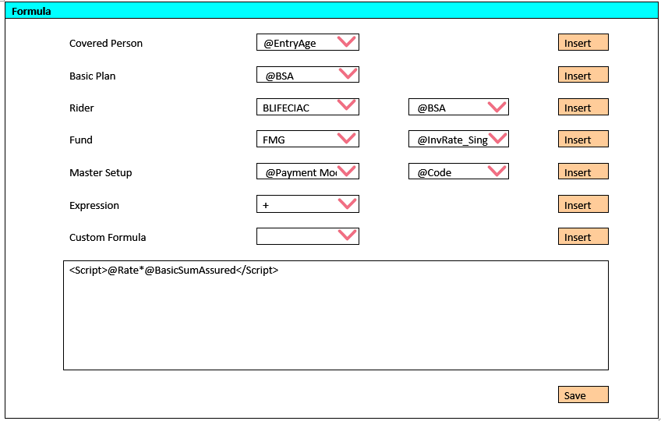

Features available

* Covered Person: - Predefined variable for Person covered. For example, @EntryAge, @Gender
* Basic Plan: - Predefined variable for Basic Plan. For example, @BSA, @Term
* Expression field – The calculation expression such as *, -, /, +., @Format
* Custom formula – formula created by user.

For more Predefined variable details, refer to Appendix 1

Validation

* The formula screen is shared among Basic Plan, Rider and Illustration.
* Rider and Fund Predefined variable will be disable in this section.
  + 1. Rider setup

The Rider setup is divided into few sub module including of Rider listing, Rider setup, Wording setup and the Rates & formula setup.

* + - 1. RIDER LISTING

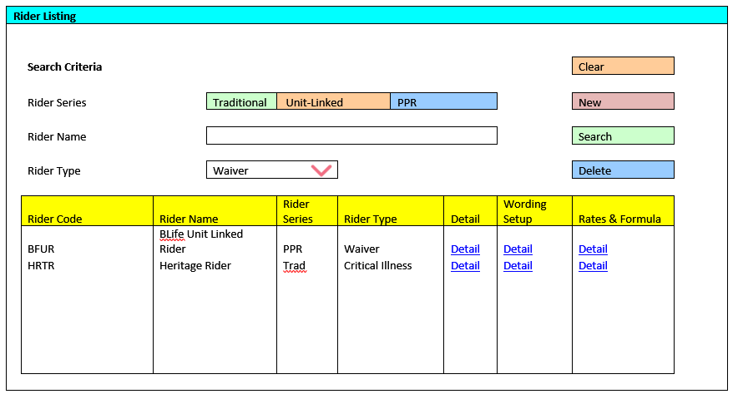

Features available

* Sorting
  + Sorting default by Rider Code
  + Rider Name
  + Rider Series
  + Rider Type
* Delete record
* Click Clear to clear the searching field such as Rider Series, Rider name and Rider Type
* Add New Record
  + - 1. RIDER SETUP

This section is to setup the Rider master information. The Rider setup can be access by clicking on the “New button” or the “Detail” column in Rider listing. Once the Riders are setup, it can be share with multiple product (user will need to do the setup in Product setting).

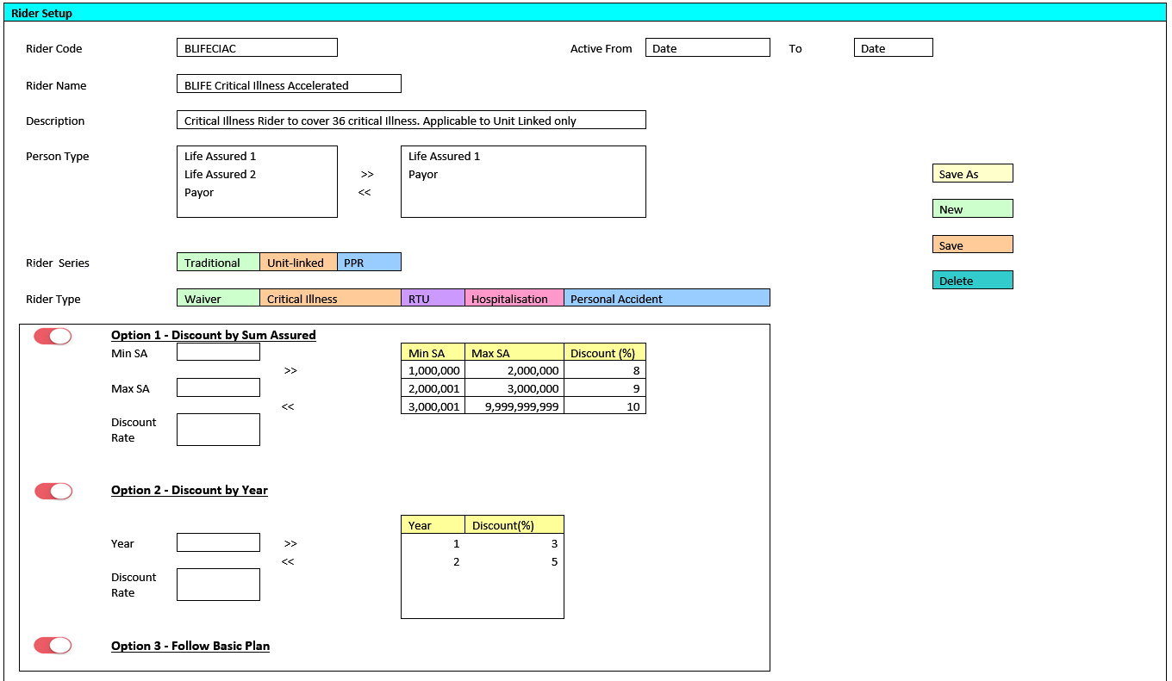

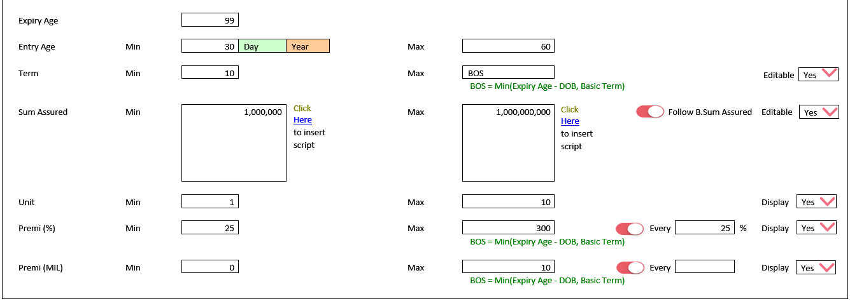

Features available

* Person Type: - The person type list are populated from Person type master. User are required to select the person type that allowable to attach to the rider during quotation proposal in BLESS.
* Active from and To – The Rider in BLESS is only active within the date period else agent are not able to view the rider in the system.
  + Rider Series: – Only Traditional, Unit-Linked and PPR option available.
  + Rider Type: - to categorize the type of rider which is Waiver, Critical Illness, RTU, Hospitalization or Personal Accident
  + Discount: - There are 3 types of discount which consists of the below and only 1 option is allow.
    - Discount by Sum Assured
    - Discount by Year
    - OR Follow Sum Assured
  + Min Entry Age: - Min Age can be set as ‘Days’ or ‘Year’
  + Term: - Editable option is available to allow or not allow agent to edit the field in BLESS
  + Min Basic Sum Assured: - Can be input as number or script
  + Max Basis Sum Assured: - Can be input as number or script
  + Min and Max Sum Assured - Min and Max Sum Assured field will be disable if user opt for "follow basic Plan".
  + Premium Loading (%): - An option available (every) to set the mod between the Min and Max value. For example: Min Premium Loading (%) is 25, Max Premium Loading (%) is 200 and the mod(Every) is set to 25. The Premium Loading (%) display in the BLESS is 25, 50, 75, 100, 125, 150, 175 and 200. There is also a Display option to set whether this field to be visible in BLESS.
  + Premi MIL – Option available (Every) to set the mod between the Min and Max vale. There is also a Display option to set if the field to be visible in BLESS.

Validation

* + Rider code ** must be unique
  + Active From **
  + Active To **
  + Rider Name **
  + Description **
  + Person Type **
  + Rider Series **
  + Rider Type **
  + Expiry Age **
  + Entry Age **
  + Term **
  + Min and Max Sum Assured field will be disable if Rider Type “Waiver” or “Follow B.Sum Assured” is selected
  + Premi Loading (%) is mandatory if Display=Yes option is selected
  + Premi MIL is mandatory field if Display=Yes option is selected

** Mandatory fields to key in.

* + - 1. RIDER WORDING SETUP

The screen is to set the wording for Rider that will display in the Quotation report. It can be access from the Riderwording column in Rider listing screen.

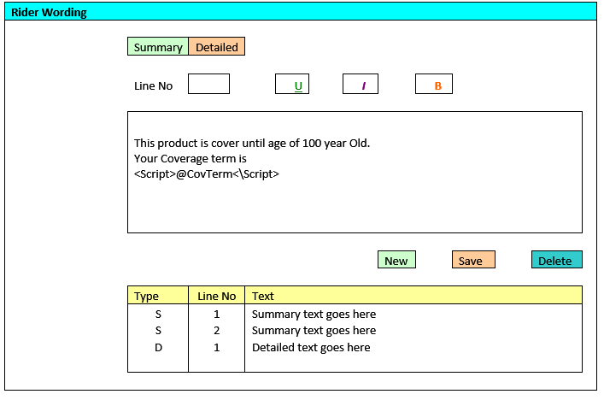

Features available

* Summary or detailed – Rider wording can add to Summary or Detailed section.
* Text can be formatted to Underline, Italic or bold.
* Script can be inserted into the Text box. The script must be started with <Script> and ended with </Script>.

Validation

* All fields are mandatory
  + - 1. RATES AND FORMULA SETUP

User can create the basic plan formula such as basic plan premium in this screen. It can be accessible from the Rates and formula column in the Basic Plan listing screen.



Validation

* Formula ID must be unique
* All fields are mandatory
  + - 1. RATES MAPPING

This screen can be accessible from the Rates and Formula setup screen by clicking on the Import rates link or the Rates Details column in the Rider listing. The purpose of this section is to import and map the rates field to the Predefined field so that the system knows where to retrieve the correct rates for calculation.

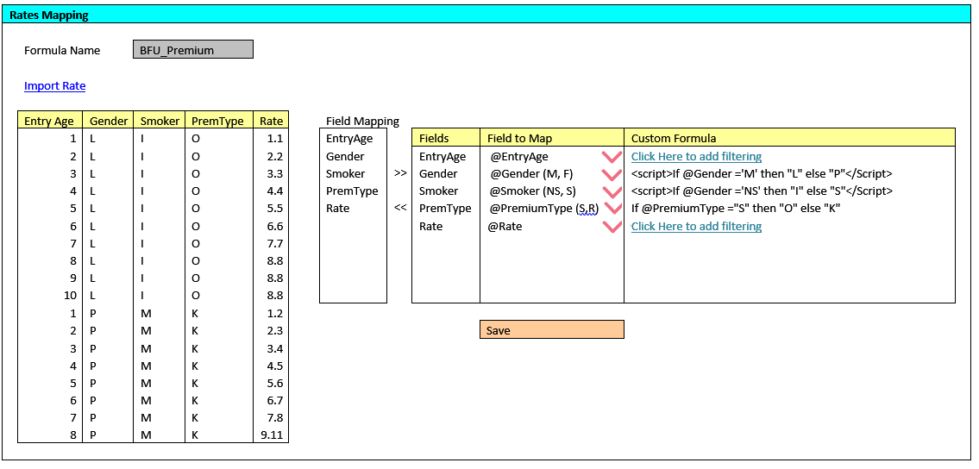

Features available

* + Import rate: - Rates to be imported from the excel file to the rates listing. Note: The system only recognizes excel format.
  + Field Mapping: - There are a list of Predefined field. User are required to map the rates field to the predefined field at the combo box provided.
  + Custom Formula –User are able to add formula to map the rates if there is special condition. The formula screen will pop up when user click on the custom formula column.(Refer to 2.2.11.6)
    - 1. FORMULA

Below screen is to serve to input formula. It can be access from the “Click here to input script” in Rates and Formula setup screen. Once formula is save, the formula will be populated to the Rates and Formula setup screen.



Features available

* Covered Person: - Predefined variable for Person covered. For example, @EntryAge, @Gender
* Basic Plan: - Predefined variable for Basic Plan. For example, @BSA, @Term
* Rider - Predefined variable for Rider.
* Expression field – The calculation expression such as *, -, /, +., @Format
* Custom formula – formula created by user.

For more Predefined variable details, refer to Appendix 1

Validation

* The formula screen is shared among Basic Plan, Rider and Illustration.
* Fund Predefined variable will be disable in this section.
  + 1. Additional wording

This section is for user to add additional wording if they wish to illustrate more information or clauses to display in the quotation.

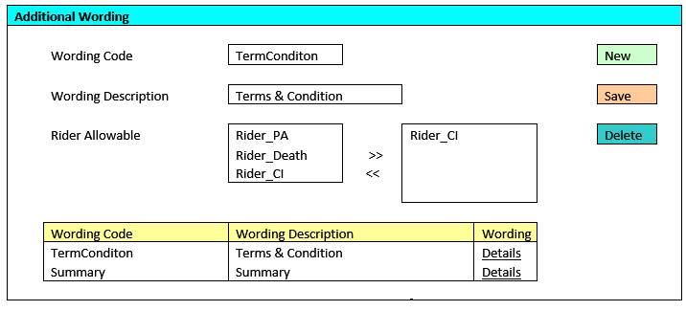

Features available

* Rider Allowable – The rider list is populated from Rider setup master. User are required to choose the rider if they wish to display the information based on the rider in the BLESS
* Add New wording
* Delete wording
* Edit wording by click the Details link

Validation

* + Wording Code ** must be unique
  + Wording description **

** Mandatory fields to key in.

* + - 1. Additional wording (Insert wording)

User can insert or maintain the wording in this section. This screen can be accessible from the Wording column in the Additional Wording Main Screen

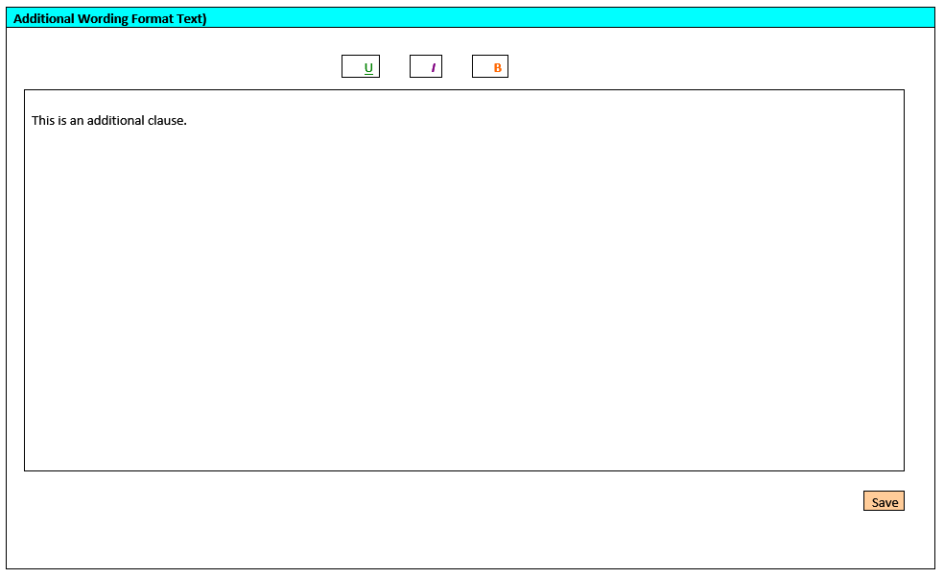

Features Available

* Text can be formatted to Underline, Italic or bold
  + 1. Product setup

Once the Basic Plan and Rider setup is completed, user can proceed product mapping. User are required to map the Basic Plan, Rider and Additional wording.

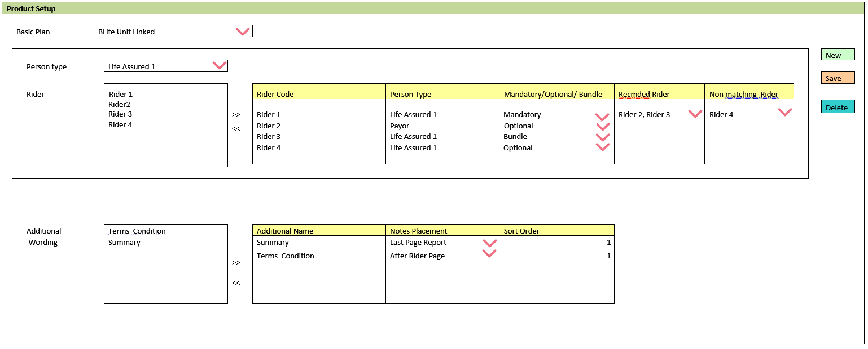

Features Available

* Basic Plan – The Basic Plan list is populated from the Basic Plan master.
* Person Type – The person type is populated from the Rider Master. Once person type is selected, a list of rider will be display in the Rider list to user to choose.
* There are 3 type of Rider attachment type
  + Mandatory – The rider is compulsory to attach to the basic plan. Agent will prompt with an error message if they failed to do so.
  + Bundle – The rider will be automatically bundle to the Basic Plan in BLESS.
  + Optional – It is optional for the agent to attach the rider to BLESS quotation stage.
* Recmded Rider – The rider must be attached to the quotation if the 1st column rider is attached
* Non Matching Rider - The rider is not allow to attached to the quotation if the 1st column rider is attach to the quotation.
  + 1. Illustration setup
       1. ILLUSTRATION TABLE SETUP

Below screen are use to create the illustration table that will display in the SI quotation. User can create more than 1 quotation table for each product to be display in the quotation table. 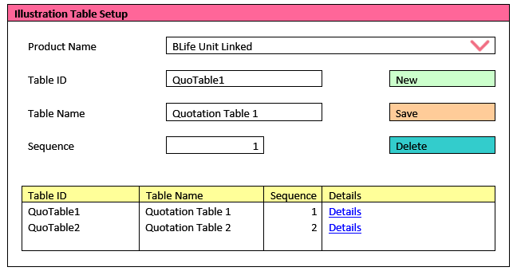

Features Available

* Product Name: - User to choose the product from the combo box provided
* Sequence: - User can define the sequence of the table to show in the SI quotation
* Delete Record
* Add New Illustration table

Validation

* Table ID must be unique
* All fields are mandatory
  + - 1. ILLUSTRATION TABLE DETAIL

Below screen can be access by clicking the “Details” column in the Illustration Table setup screen. This screen is for the user to create the illustration table column for the particular illustration table.

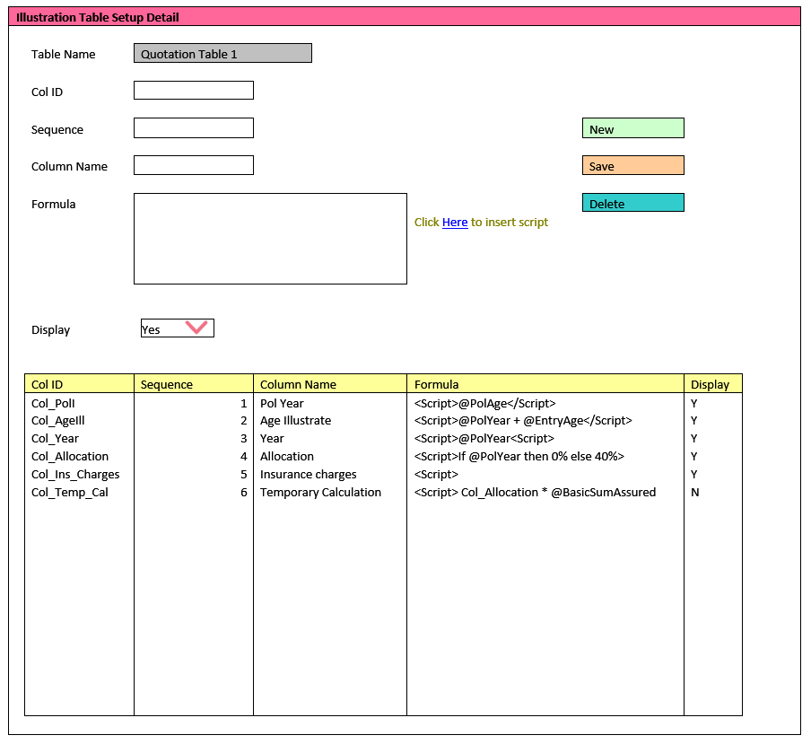

Features Available

* Column name: – the column name created will show in the illustration table’s column header.
* Display option is available to set not to display the column in the illustration table

Validation

* Col ID must be unique
* All field are mandatory
  + - 1. Formula

Below screen is to serve to input formula. The formula set in this section can be access from the “Click here to input script” in the Illustration Table Setup Detail Screen.

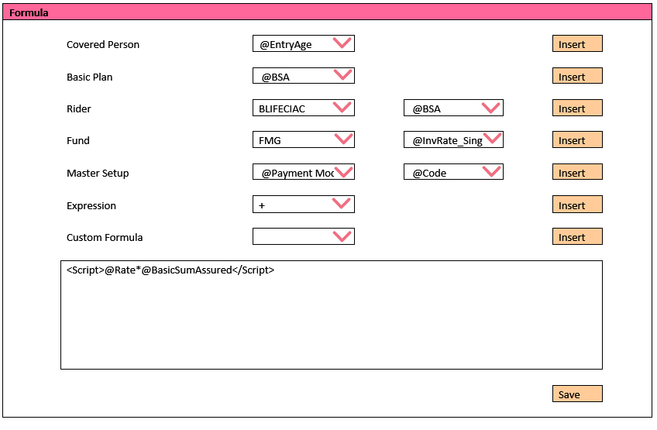

Features available

* Covered Person: - Predefined variable for Person covered. For example, @EntryAge, @Gender
* Basic Plan: - Predefined variable for Basic Plan. For example, @BSA, @Term
* Rider: -Predefined variable for Rider.
* Fund: - Predefined variable for Fund
* Master Setup: Some Predefined variable from Master setup.
* Expression field – The calculation expression such as *, -, /, +., @Format
* Custom formula – formula created by user.

For more Predefined variable details, refer to Appendix 1

* + - 1. IMPORT RATES

The section below is use to create the Rates table.

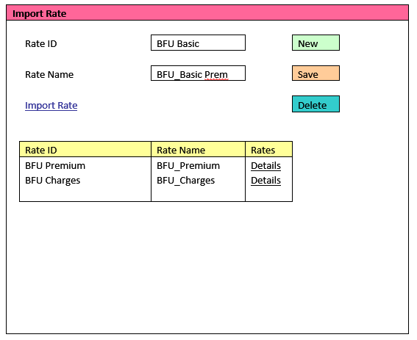

Validation

* Rate ID must be unique
* Rate name is mandatory
* Delete rate
* Add new Rate
* Edit rate by click on the listing record
  + - 1. FIELD MAPPING

This screen can be accessible from “import rate” link or Details column in the Import Rate screen

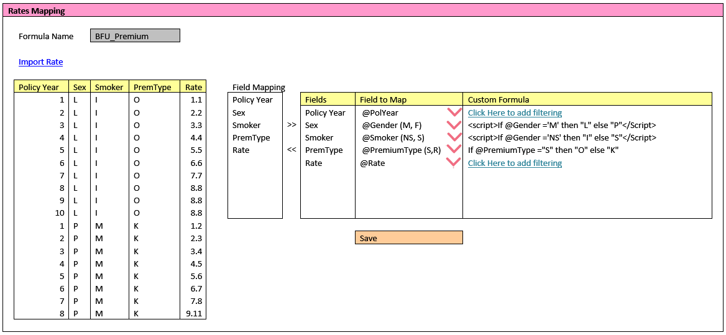

Features available

* + - Import rate: - Rates to be imported from the excel file to the rates listing. Note: The system only recognizes excel format.
    - Field Mapping: - There are a list of Predefined field. User are required to map the rates field to the predefined field at the combo box provided.
    - Custom Formula –User are able to add formula to map the rates if there is special condition. The formula screen will pop up when user click on the custom formula column.
    1. Product compilation

This section is to compile the product setting into a single file and the

file will be compile with BLESS application and release for agent to

use.

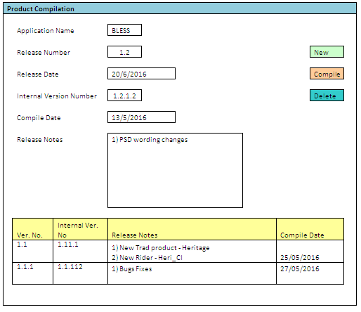

Features available

* Able to store the history release notes for each version
* Release Number, Release Date and Release notes can be view by agent in BLESS

Validation

* Release number must be unique
* All fields are mandatory
  + 1. Appendix

Below are the sample of predefined variable that will build in the

system. The predefined variable can be seen in the Formula screen

|  |  |  |  |
| --- | --- | --- | --- |
| Category | 1st Level Dropdown | 2n Level Dropdown | Remark/ Sample |
| Covered Person | @EntryAge |  |  |
|  | @PolAge |  | Example script: |
|  | @Smoker (NS, S) |  | <Script> If @Smoker ='NS' then "L" else "K"</Script> |
|  | @Gender (M, F) |  | <Script>If @Gender ='F' then "M" else "K"</Script> |
| Basic Plan | @BSA |  |  |
|  | @Term |  | Example script: |
|  | @Prem_Holiday |  | <Script>If @Term <=99 then 0</Script> |
|  | @Premi% |  |  |
|  | @Premi%_Term |  |  |
|  | @PremiMIL |  |  |
|  | @PremiMIL_Term |  |  |
| Rider | Code | @Code | Rider listing listed is based on the rider allowable set in the basic product setup |
|  |  | @RSA |  |
|  |  | @Term |  |
|  |  | @Premi% |  |
|  |  | @Premi%_Term |  |
|  |  | @PremiMIL |  |
|  |  | @PremiMIL_Term |  |
| Fund | Code | @Code | Fund listing listed is based on the fund allowable set in the basic product setup |
|  | Investment Rate | @InvRate_Single |  |
|  |  | @InvRate_Yearly |  |
|  |  | @InvRate_SemiAnn |  |
|  |  | @InvRate_Quarterly |  |
|  |  | @InvRate_Monthly |  |
|  | Investment Return | @High |  |
|  |  | @Medium |  |
|  |  | @Low |  |
| Master Table | Payment Mode | @Code |  |
|  | Channel | @Code |  |
|  | Occupation | @Code |  |
|  |  | @OccClass |  |
| Expression | - |  |  |
|  | + |  |  |
|  | / |  |  |
|  | ( |  |  |
|  | ) |  |  |
|  | * |  |  |
|  | t-1 |  |  |
|  | PV |  |  |
|  | FV |  |  |
|  | Min |  |  |
|  | Max |  |  |